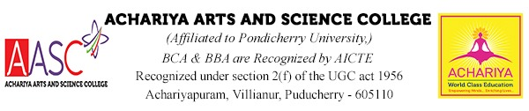

DEPARTMENT OF COMPUTER APPLICATIONS (BCA)

About the Department
History
Established in 2004, the Department of Computer Applications was founded to meet the growing demand for highly skilled professionals in the field of computing. The department offers a four-years Bachelor of Computer Applications (BCA Honors) program Under the National Education Policy NEP -2020 designed to provide students with a strong foundation in computer science theory alongside practical expertise in software and application development.
Our team of dedicated and highly qualified faculty members is committed to guiding students toward academic excellence and professional success. Over the years, the majority of our graduates have secured rewarding placements or pursued higher education, reflecting the department’s emphasis on career readiness and lifelong learning.
To support hands-on training, the department is equipped with a state-of-the-art computer laboratory featuring the latest software tools. Students gain extensive practical experience across multiple programming languages, ensuring they are well-prepared to excel in the dynamic technology industry.

Objectives
- Provide a strong foundation in computing concepts and business practices to effectively manage enterprise software and information systems.
- Develop analytical skills for system development, enabling students to assess organizational needs and design efficient solutions.
- Equip graduates with software development expertise to pursue careers or entrepreneurial opportunities in both Indian and global markets.
- Offer specialization pathways in legacy application software, system software, and mobile application development to meet diverse industry demands.

Vision
To be a leading center of excellence in computer applications education, fostering innovation, practical expertise, and global competitiveness. The department envisions producing graduates who are technically proficient, entrepreneurial, and adaptable to the ever-evolving digital landscape.

Mission
- Deliver quality education in computer science and applications through a balanced blend of theory and practical training.
- Empower students with industry-relevant skills in software development, system analysis, and emerging technologies.
- Promote innovation and research by encouraging creative problem-solving and lifelong learning.
- Prepare graduates for global opportunities by instilling professionalism, ethical values, and adaptability to diverse work environments.

